**Setting up Application Environment**

**Create Send Grid Account**

|  |  |
| --- | --- |
| Team ID | PNT2022TMID19795 |

**Step 1:** Navigate to https://sendgrid.com

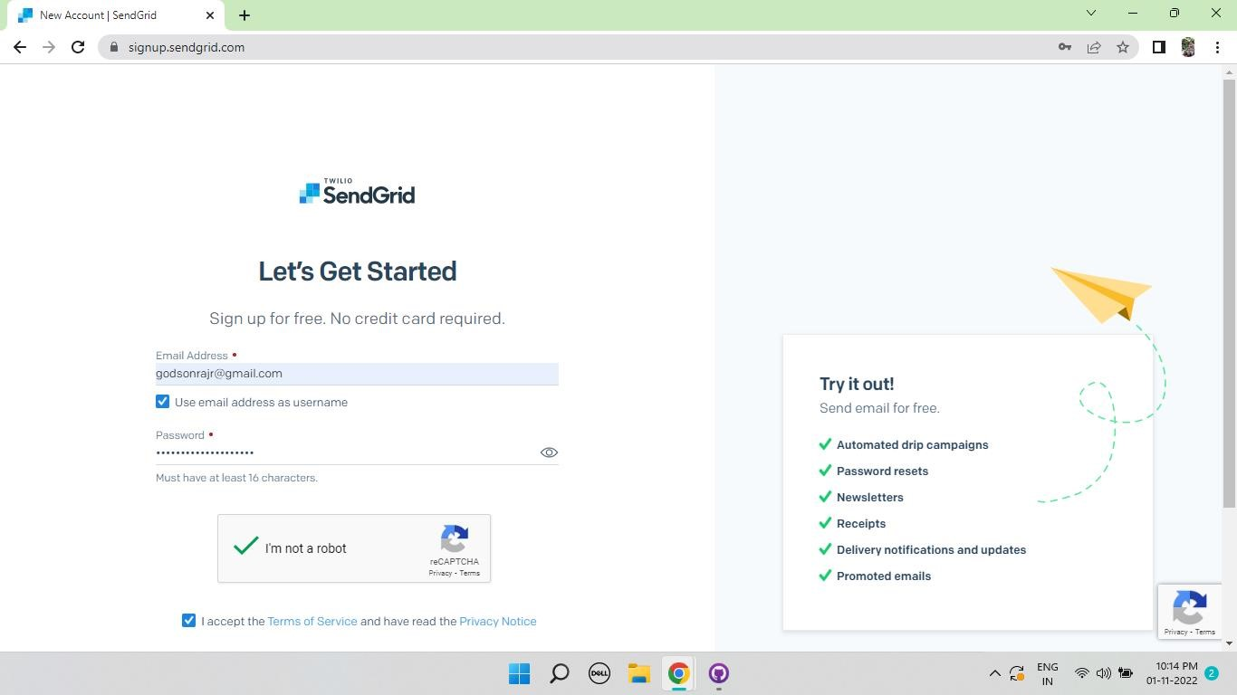

**Step 2:** Click on “Start for free” and register yourselves by entering required details and click on create account.

**Step 3:** Further fill all required details in next page and click on get started.

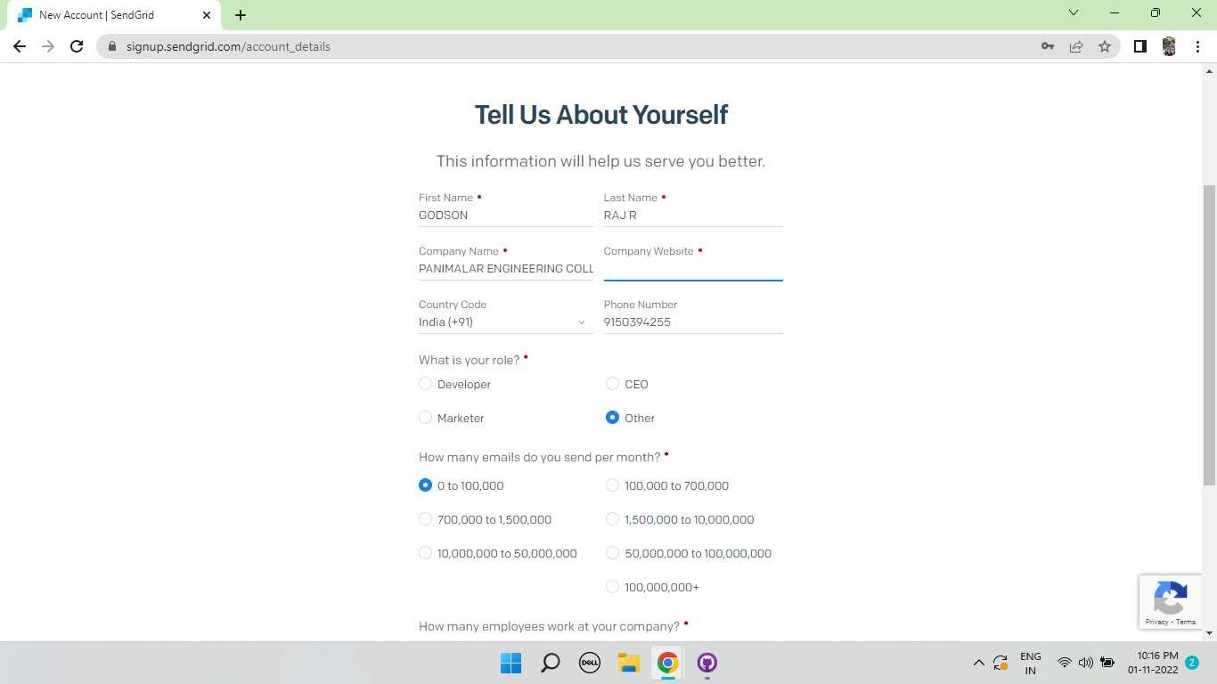

**Step 4:** That’s it you have created your Send Grid account and got access to dashboard.

**Output:** Send Grid account created successfully.

